Create Node-RED Service

Aim: To create a web application create a Node-RED service.

Steps followed:

* 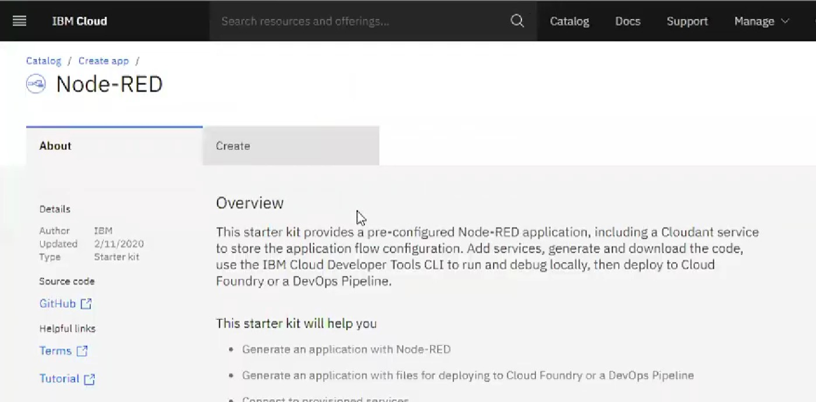Navigated to the App creation page
* Entered project details and clicked on create

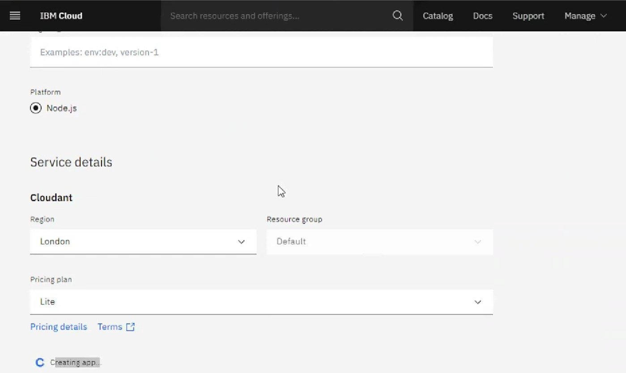

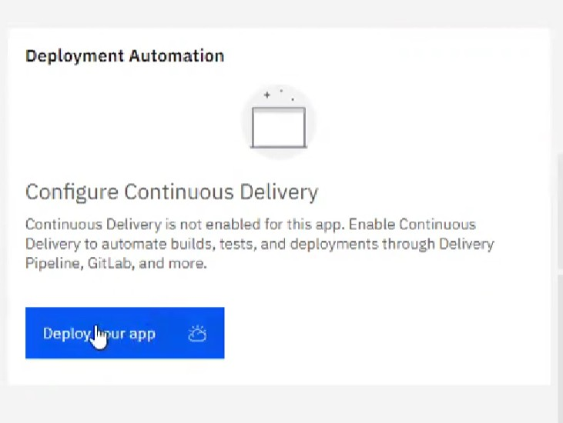

* 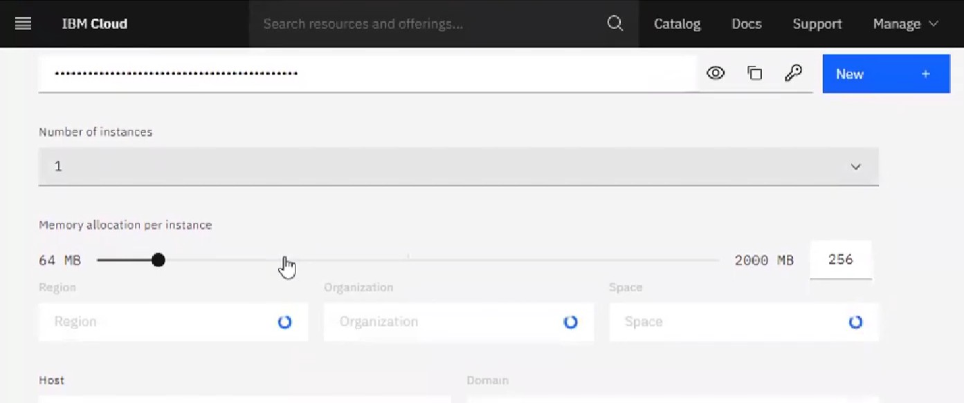Setting up the environment and deploying the app

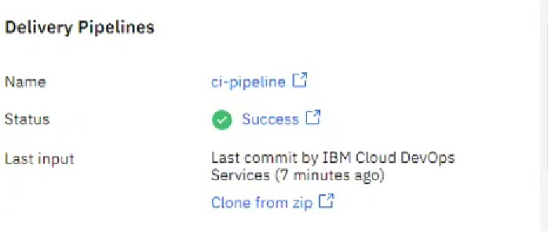

* 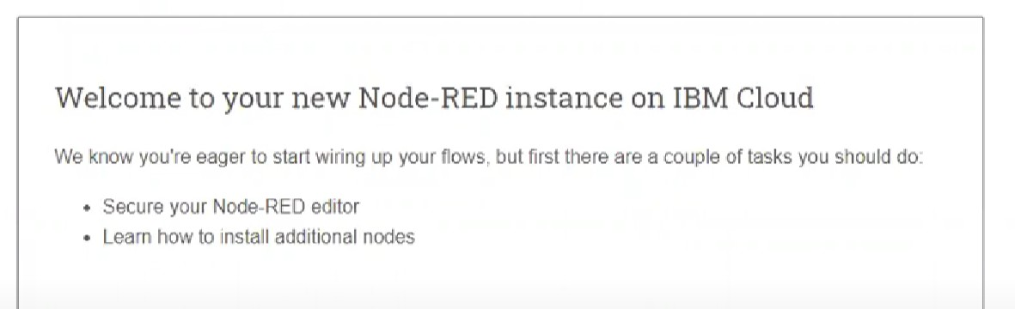Welcomed by the instance editor
* Setting up credentials

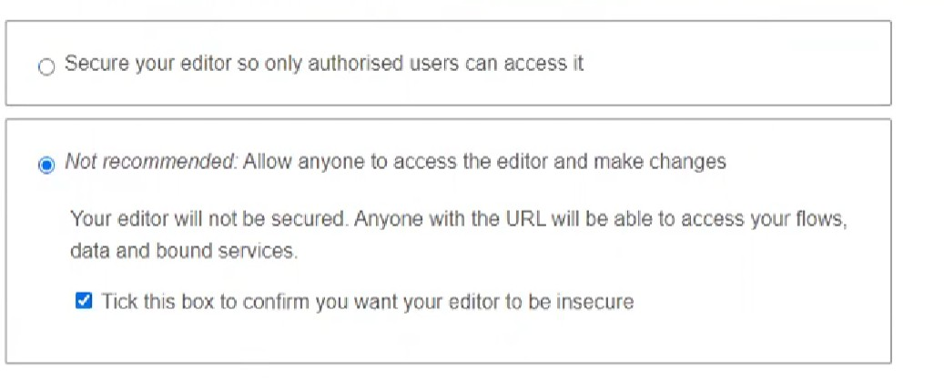

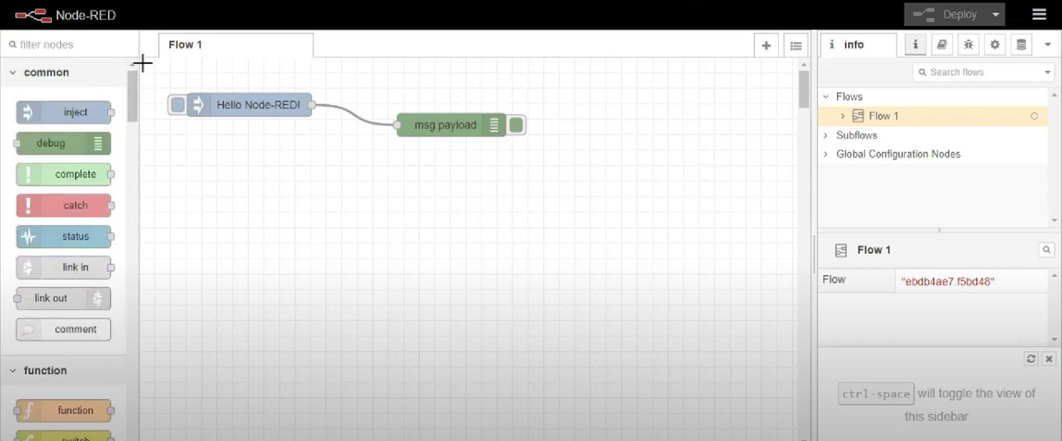

* 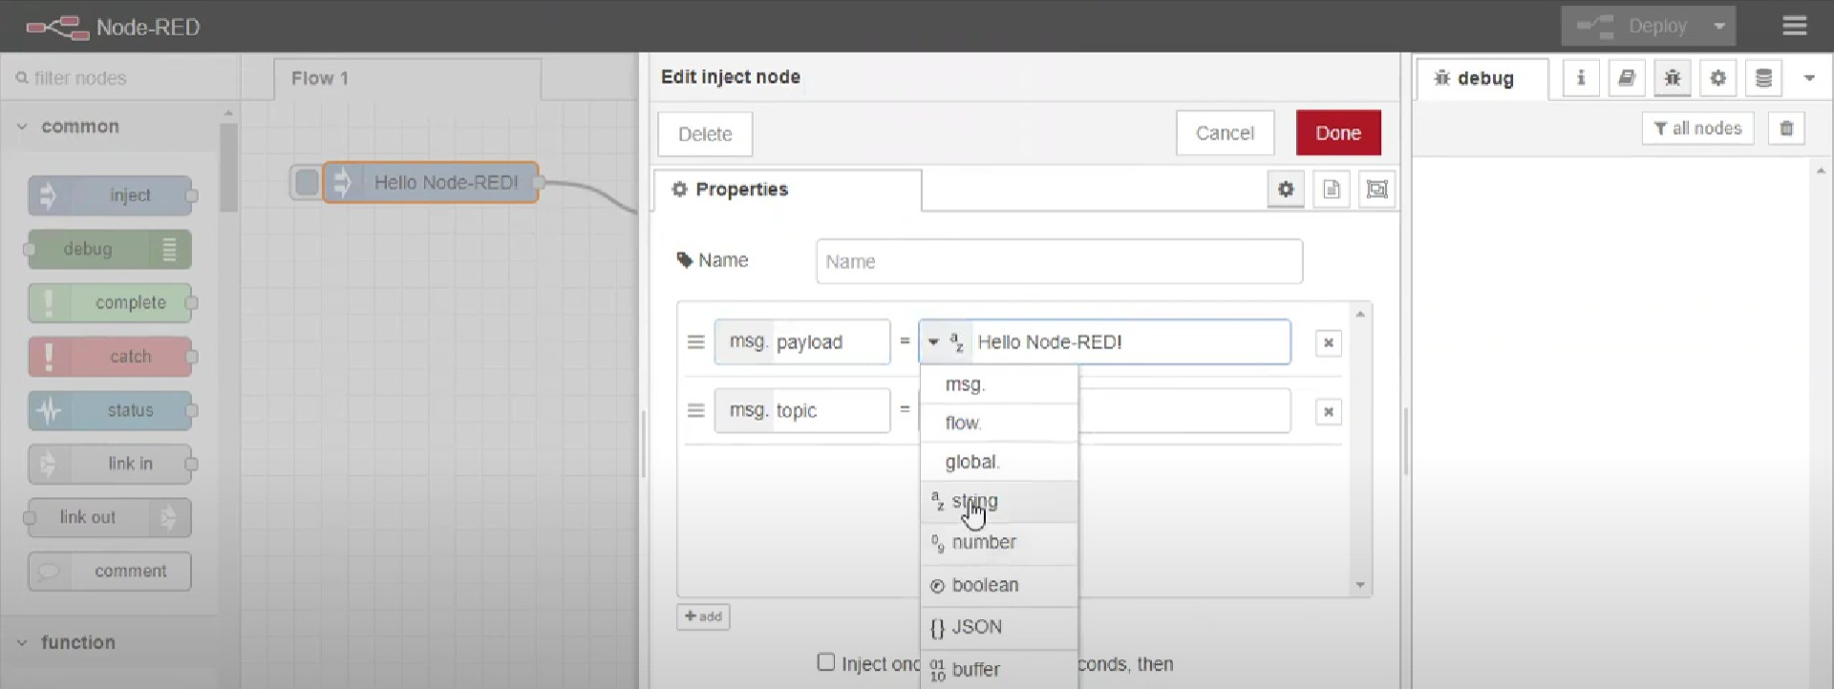Editing some values of the properties
* Successfully deployed the app

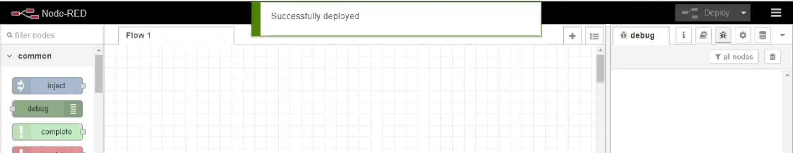

Result: Successfully created a NodeRED service on IBM Cloud